Brandon Fisher

CSC 414 Software Development

November 17, 2020

“Project Development Paper”

**Section 1.0**

**1.0: Scope**

This document will bring into detail a program.

**1.1: Identification**

This document can be applied to any windows or mac running its up to date software. Also, the program itself will be done and viewed in C++.

**1.2: System Overview**

The main point of the program is to allow the input of five names that will be organized alphabetically and be able to be viewed in a document.

**1.3: Document Overview**

The main purpose of this document is to detail the organization of ‘items’ in a program.

**Section 2.0**

**References:**

[1] C++ Programming From Problem Analysis to Program Design by D.S. Malik

[2] “What is the std::sort() function in C++”. <https://www.educative.io/edpresso/what-is-the-stdsort-function-in-cpp>. Accessed 17 November 2020.

[3] Chakraborty, Arnab. ”Sort an Array of Strings According to String Lengths in C++”. <https://tutorialspoint.com/sort-an-array-of-strings-according-to-string-lengths-in-cplusplus>. Accessed 17 November 2020.

**Section 3.0**

**Requirements:**

* It shall allow only an input of five names.
* It shall sort the names alphabetically.
* It shall print the results to a readable TXT file.
* Any method to sort the names is allowed.

**Section 4.0**

**Design:**

A user interface pops up allowing a maximum of five names to be inputted. Everything else is done in the backdrop and closes accordingly.

**Section 5.0**

**Test:**

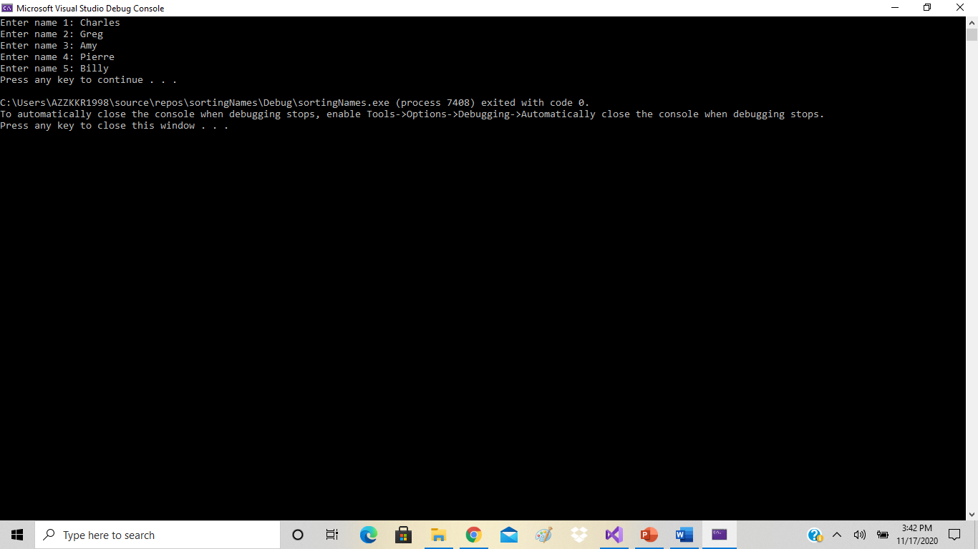

**Appendix**

**Test Results:**

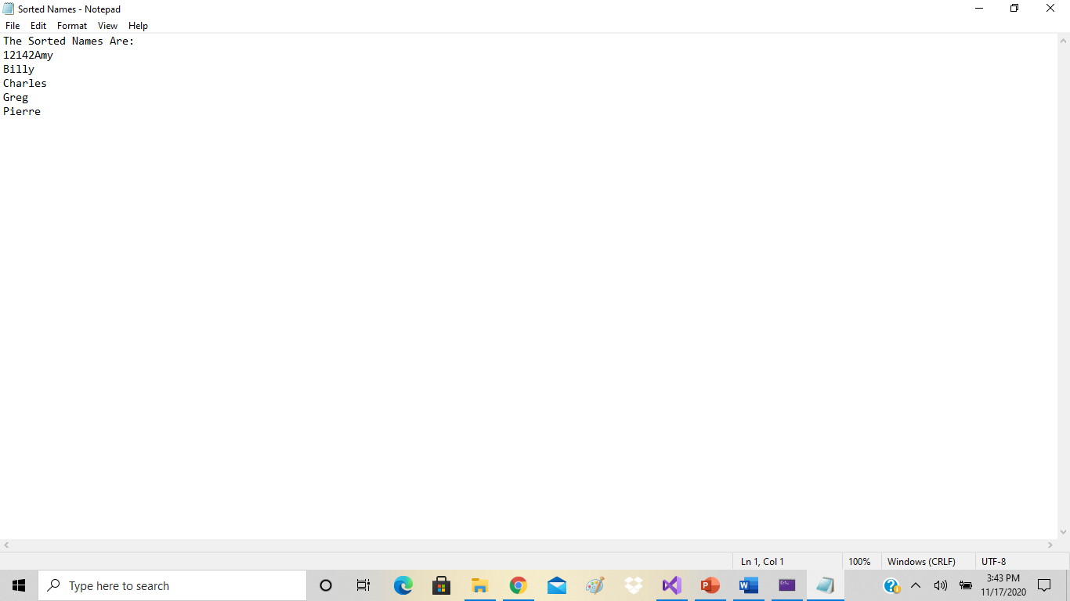

**Index:**

1. **– Scope, Identification, Etc**

**2.0 - References**

**3.0 – Requirements**

**4.0 – Design**

**5.0 – Test**

**Test Results**